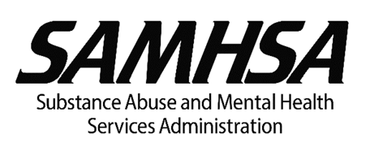

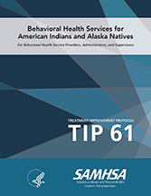
Sharing TIP 61 on Social Media

We encourage you to spread the word about the Substance Abuse and Mental Health Services Administration’s new Treatment Improvement Protocol (TIP) by sharing it on social media. Below are some sample messages that you can use to share Treatment Improvement Protocol (TIP) 61, Behavioral Health Services for American Indians and Alaska Natives, with your networks.

Twitter:
SAMHSA’s NEW resource, TIP 61: Behavioral Health Services for American Indians and Alaska Natives provides guidance on providing culturally responsive treatment: http://bit.ly/2DTjVvB

Improve access to and engagement in culturally responsive substance use and mental health treatment for American Indians and Alaska Natives. Learn more from SAMHSA’s NEW TIP: http://bit.ly/2DTjVvB

Historical trauma, cultural perspectives, and access to services affect the health of American Indians and Alaska Natives. Learn more from SAMHSA’s TIP 61: Behavioral Health Services for American Indians and Alaska Natives: http://bit.ly/2DTjVvB

Facebook:
American Indians and Alaska Natives have consistently experienced disparities in access to health education and prevention services; access to healthcare services, funding, and resources; quality and quantity of healthcare services; recovery support services; and treatment outcomes. SAMHSA’s newest resource, TIP 61: Behavioral Health Services for American Indians and Alaska Natives, provides guidance on culturally responsive treatment. Download today: http://bit.ly/2DTjVvB

You can also connect with SAMHSA on Twitter and Facebook:
Share on Twitter
Share on Facebook

KAP is operated through a Joint Venture of The CDM Group, Inc., and JBS International, Inc.
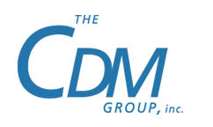

The CDM Group, Inc.
7500 Old Georgetown Road, 9th Floor
Bethesda, MD 20814
Tel: 301.654.6740
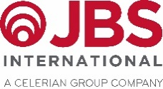
JBS International, Inc.
5515 Security Lane, Suite 800
North Bethesda, MD 20852
Tel: 301.495.1080

